**Music Flow Analytics**

**Abstract:**

This project aims to enhance the user experience of a music streaming service, such as Spotify, by analyzing user data. To achieve this, AWS Redshift is utilized to collect information about user preferences and behaviors. Subsequently, Apache Kafka and OLAP processing are employed to analyze the data and extract valuable insights. The insights obtained will be utilized to optimize the app and enhance the user experience.

**Overview:**

The project involves collecting data from two sources: event logs from the app usage and a database of songs and artists. This data is then stored in Apache Kafka using Kafka topics, allowing for real-time storage and organization. The data is then extracted and transformed using a streaming ETL process, to make it more suitable for OLAP. Staging tables are created in Amazon Redshift to store the transformed data, which is then transformed into a Star Schema using Redshift's SQL-to-SQL transformation feature. Finally, OLAP processing is used to analyze the data and generate insights for improving the app.

**Proposed Work:**

In the proposed work, instead of Amazon S3, I plan to use Apache Kafka as the data storage for a fictional music service like Spotify. By utilizing AWS Redshift, we aim to extract valuable insights about the types of users and their interests in the app, enabling us to provide strategic recommendations for improving the program. The project's goal is to implement a data warehouse with Real time processing, Low latency, Scalable and Flexible.

**New Feature:**

This involves integrating Apache Kafka with the existing architecture of the music streaming service so that data can be collected and processed in real-time.

**Design**:

The system is designed to collect and process user data in a way that allows for deep insights into user behavior and preferences. The system consists of several components, including Apache Kafka, a streaming ETL process, Amazon Redshift, and OLAP processing tools. These components interact with each other seamlessly, allowing for real-time data processing and analysis.

**Architecture:**

The software architecture of the system involves several components, each with its own interfaces and implementation details. Apache Kafka is used for real-time data storage and organization, while the streaming ETL process transforms the data into a more suitable format for OLAP. Amazon Redshift is used to store the transformed data in staging tables, which are then transformed into a Star Schema using Redshift's SQL-to-SQL transformation feature. OLAP processing tools are used to analyze the data and generate insights for app optimization.

**Methodology:**

**Online Transaction Processing(OLTP):**In day-to-day operations, businesses typically rely on OLTP (Online Transaction Processing) to process transactions, such as those performed by ATMs, vending machines, and text messaging. OLTP systems have been in use for over 40 years and are designed for high-speed data processing with reliable data integrity across numerous sequences. Each row of the table is saved as an OLTP object, and the system performs a check on each row of the query. OLTP is preferred for its ability to perform ACID (Atomicity, Consistency, Isolation, Durability) transactions, ensuring data integrity in the event of errors or outages.

In contrast, data warehouses use OLAP (Online Analytical Processing) to conduct queries, where each column is stored as an object. OLAP is optimized for analyzing large datasets to identify patterns and can also skip data and search for specific facts that need to be aggregated.

**Database:**The database's main objective is to store OLTP-generated data, making it accessible and valuable to business intelligence (BI) applications. By doing so, the company can utilize quantitative metrics to answer queries regarding app usage and make informed decisions. However, querying the data can be challenging if not done correctly. The data is stored in a directory of JSON logs, containing information on user activity within the app, as well as a directory with JSON metadata on the app's songs. The Postgres database and ETL pipeline are designed to optimize queries and provide insights into what songs users are listening to.

**ETL pipeline:**

1. Load AWS credentials.
2. Read data from Apache kafka using a kafka consumer.
3. Process the data using Apache Spark.
4. Transform the data and create tables.
5. Write the data back to Apache Kafka using a Kafka Producer.

**Implementation:**

1. Set up an Amazon EC2 instance: Start by launching an EC2 instance in the AWS Management Console and selecting the appropriate instance type based on the expected workload. Install the necessary software components such as Python, Kafka, and Zookeeper on the instance.
2. Configure Apache Kafka: Configure the Kafka instance to accept incoming data from the sources. Create a Kafka topic for each source of data, for example, one topic for event logs and another for the database of songs and artists.
3. Set up a producer: Create a producer in the EC2 instance to produce the data and send it to the Kafka topics. The producer can be written in a language of choice, such as Python or Java.
4. Set up a consumer: Create a consumer to read the data from the Kafka topics. The consumer can be written in a language of choice, such as Python or Java.
5. Verify data flow: Test the setup by sending data from the sources to the Kafka topics and verifying that it is being correctly consumed by the consumers.
6. Monitor and manage the Kafka cluster: Use the appropriate monitoring tools to ensure that the Kafka cluster is running smoothly and to manage its resources as needed.
7. Develop an ETL pipeline using the chosen ETL software. The pipeline should extract data from the Kafka topics, transform the data into a more suitable format for OLAP, and then load the transformed data into the staging tables in Amazon Redshift.
8. Test the ETL pipeline to ensure that it is working correctly.
9. Schedule the ETL pipeline to run automatically at regular intervals to ensure that the data is continuously transformed and loaded into the staging tables.
10. Launch an Amazon Redshift cluster and configure it with the appropriate node type, number of nodes, and other settings based on your data volume and processing requirements.
11. Connect to the Amazon Redshift cluster using a SQL client tool such as SQL Workbench/J or Amazon Redshift Query Editor.
12. Create the required database schema and tables in Amazon Redshift using SQL DDL statements. This includes creating the staging tables to store the transformed data.
13. Configure your ETL process to load the transformed data into the appropriate staging tables in Amazon Redshift.
14. Monitor the data loading process and troubleshoot any errors or performance issues that arise.
15. Test the data stored in the staging tables to ensure that it is complete, accurate, and in the correct format for further analysis.
16. Create a Redshift table with the desired schema to receive data from Kafka.
17. Use the COPY command to load data from Kafka to the Redshift table.
18. Use Redshift's SQL-to-SQL transformation feature to transform the data from the staging tables into a Star Schema.
19. Verify the transformed data by running sample queries against the Star Schema.
20. Connect to the Amazon Redshift cluster using a Python library like psycopg2
21. Write SQL queries to extract data from the star schema tables in Redshift.
22. Use Python's data analysis libraries like pandas or numpy to perform complex data transformations and aggregations on the data.
23. Use data visualization libraries like matplotlib or seaborn to create visualizations of the analyzed data.
24. Generate reports using Python libraries like reportlab or jupyter notebook to present the results of the analysis and visualizations.

**Redshift Cluster:**

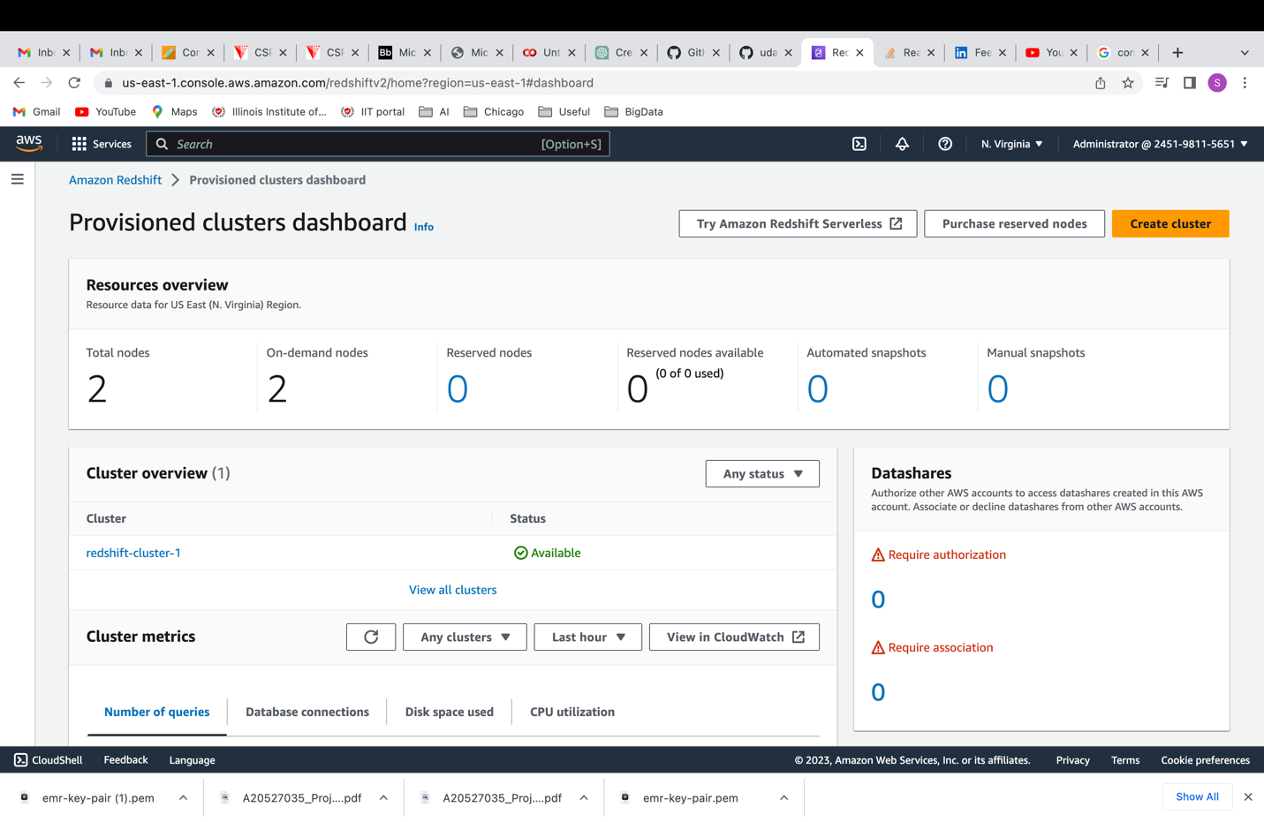

etl.py:

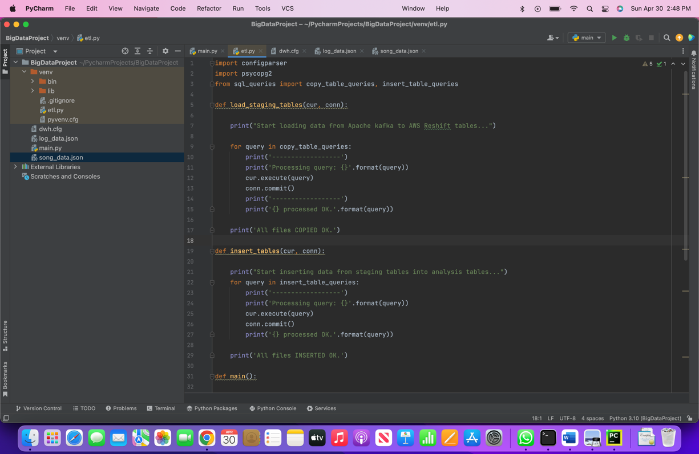

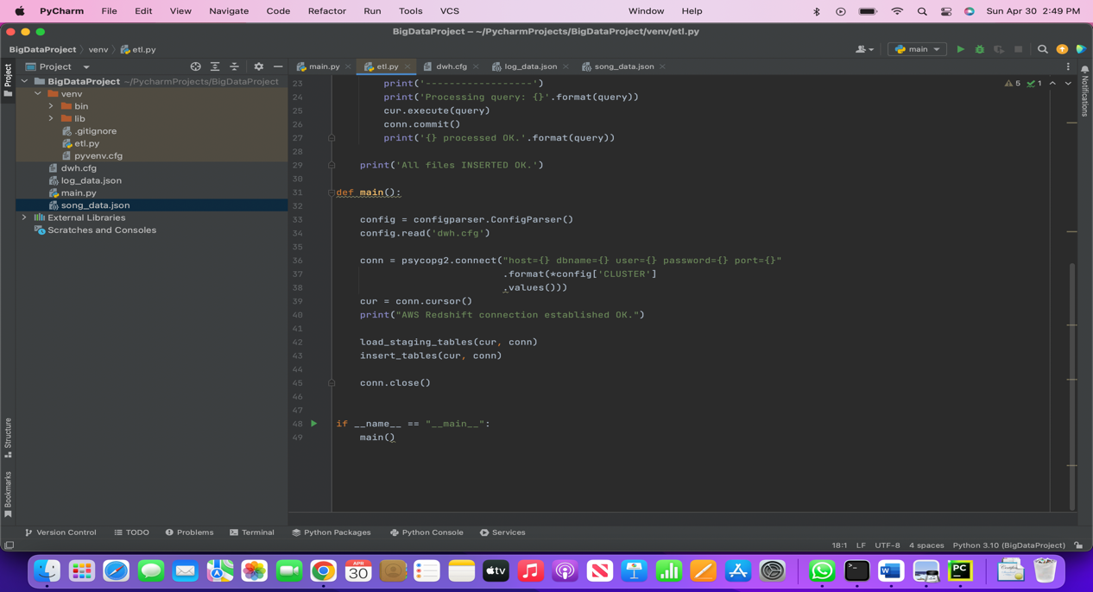

dwh.cfg:

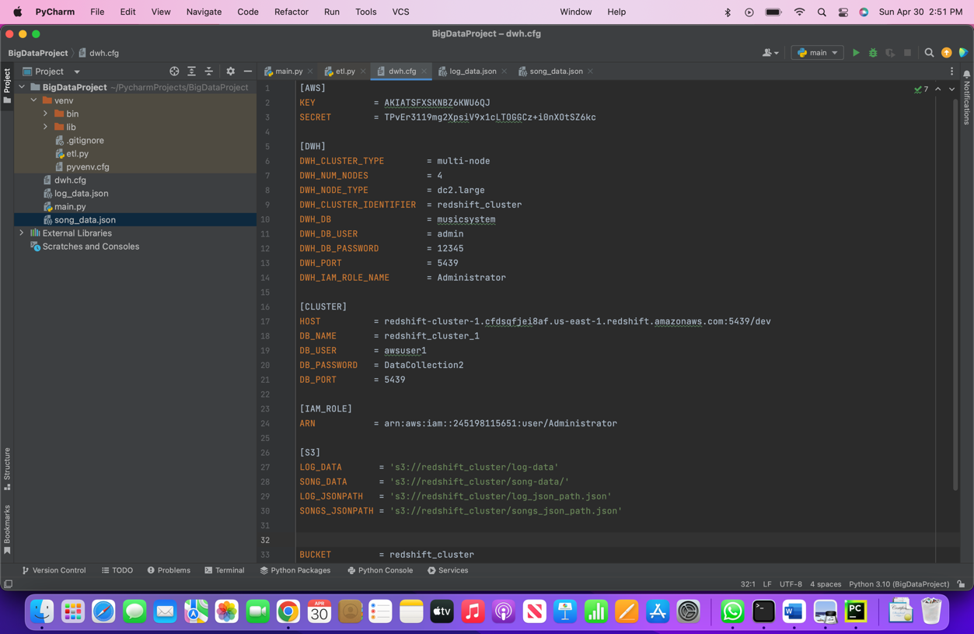

**Datasets:**

Log_data.json:

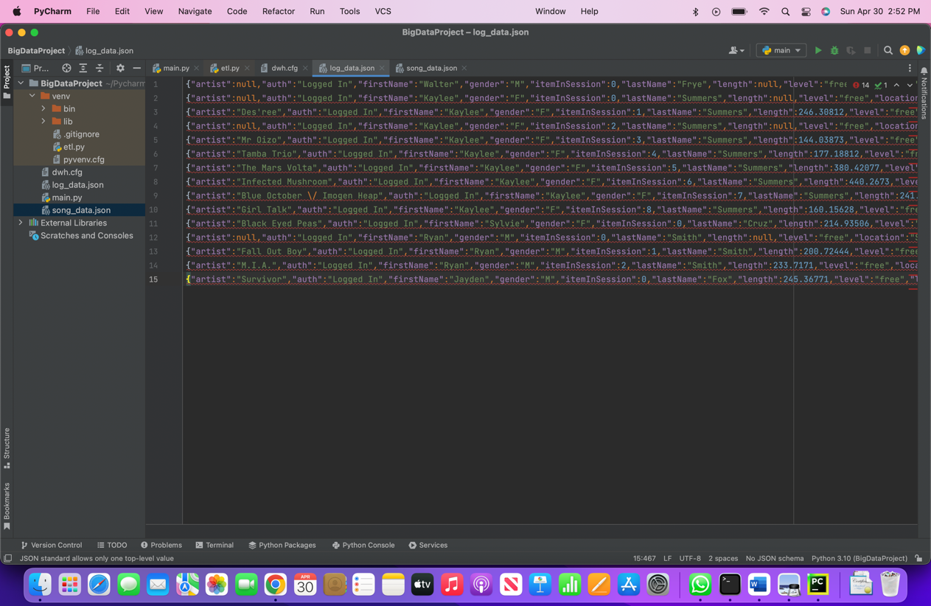

Song_data.json:

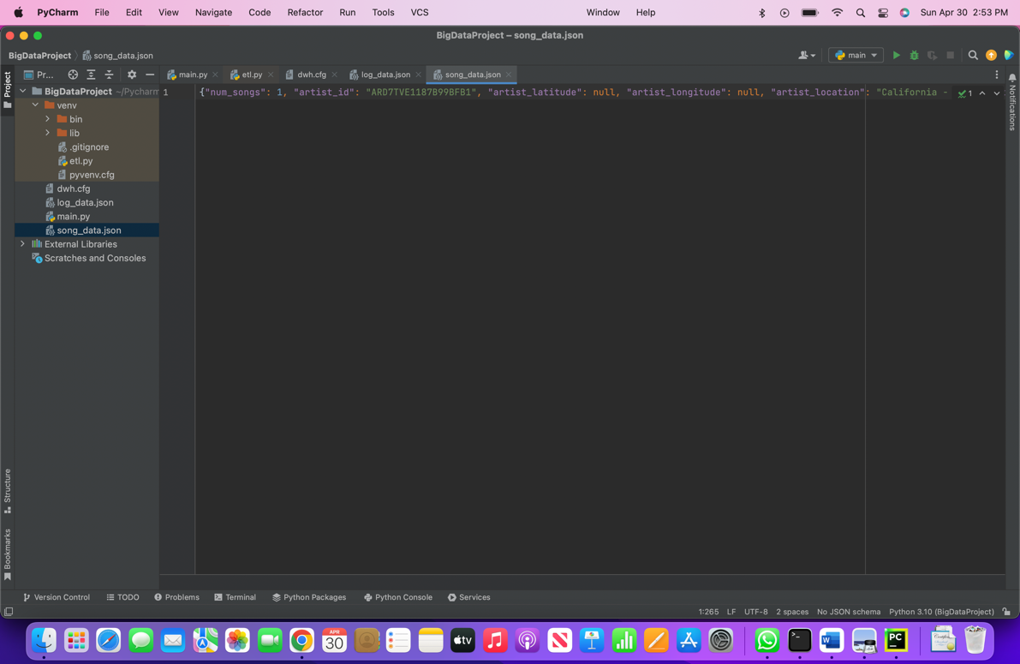

**Create_tables.py:**

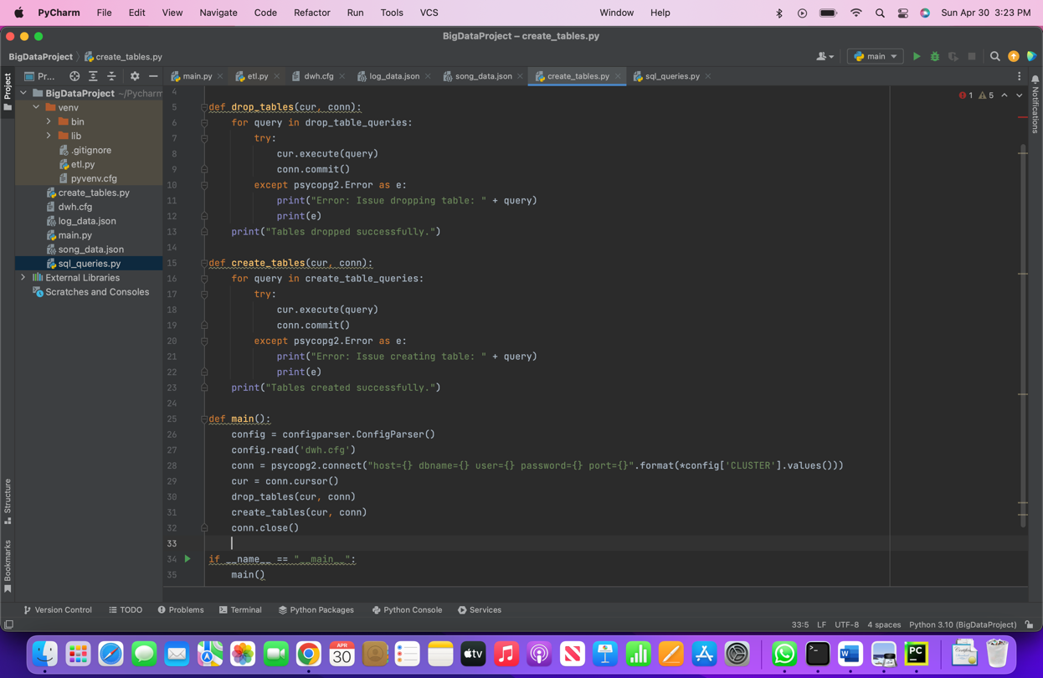

**Sql_queries.py:**

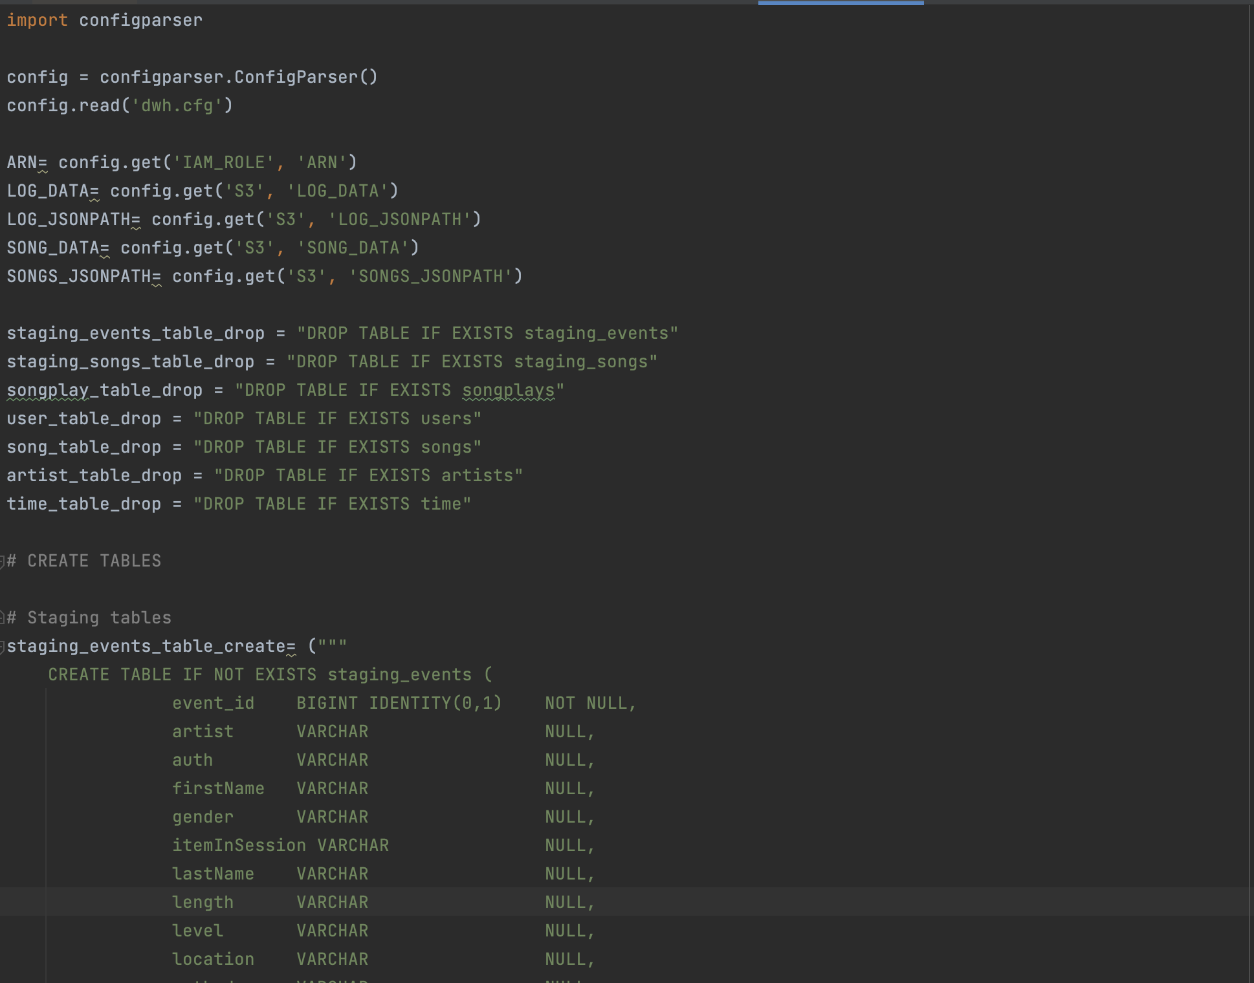

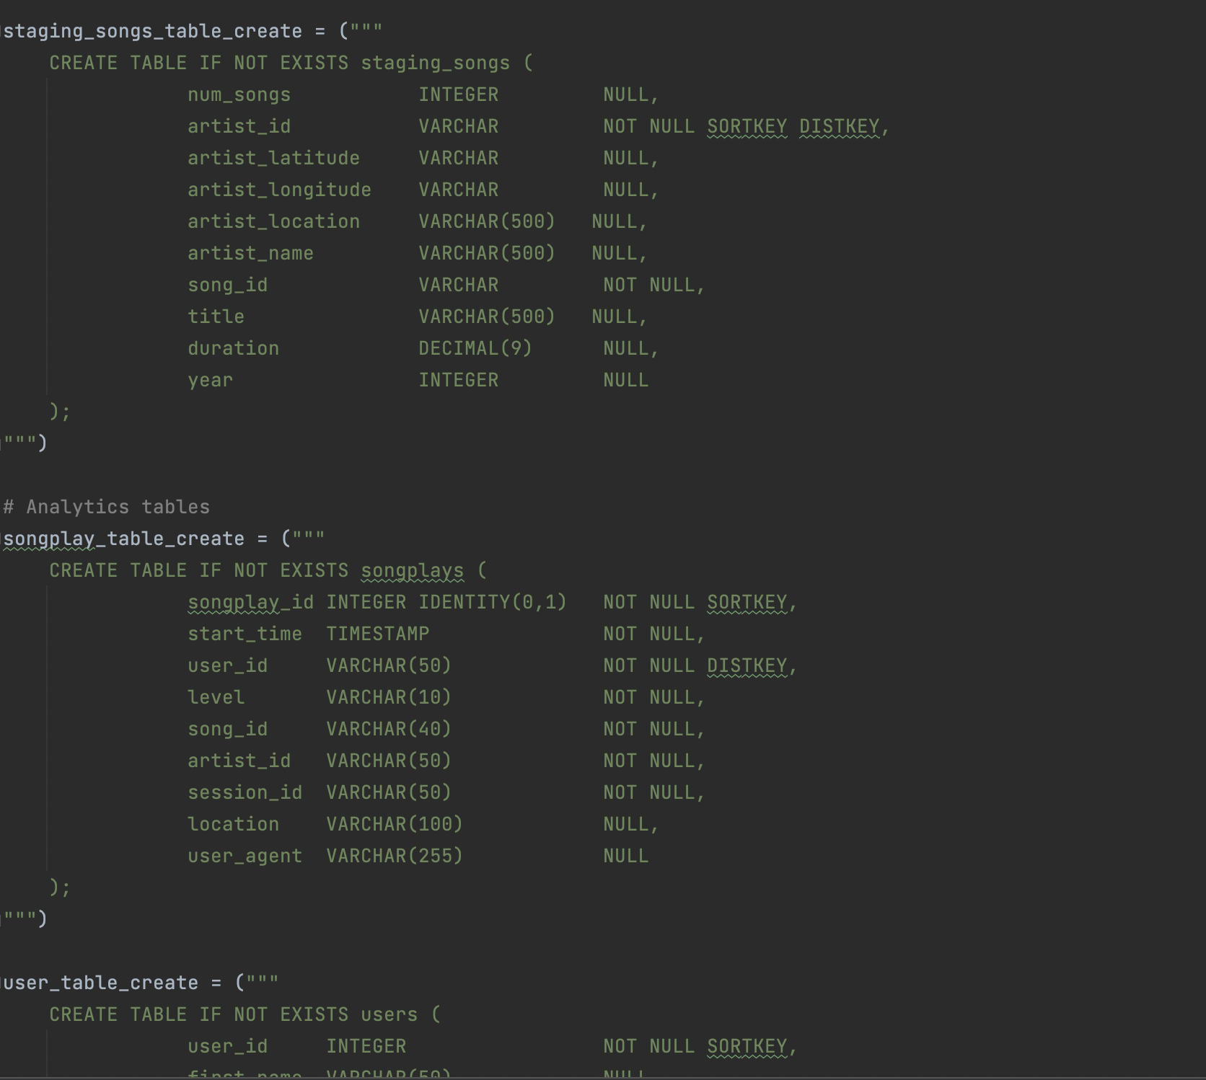

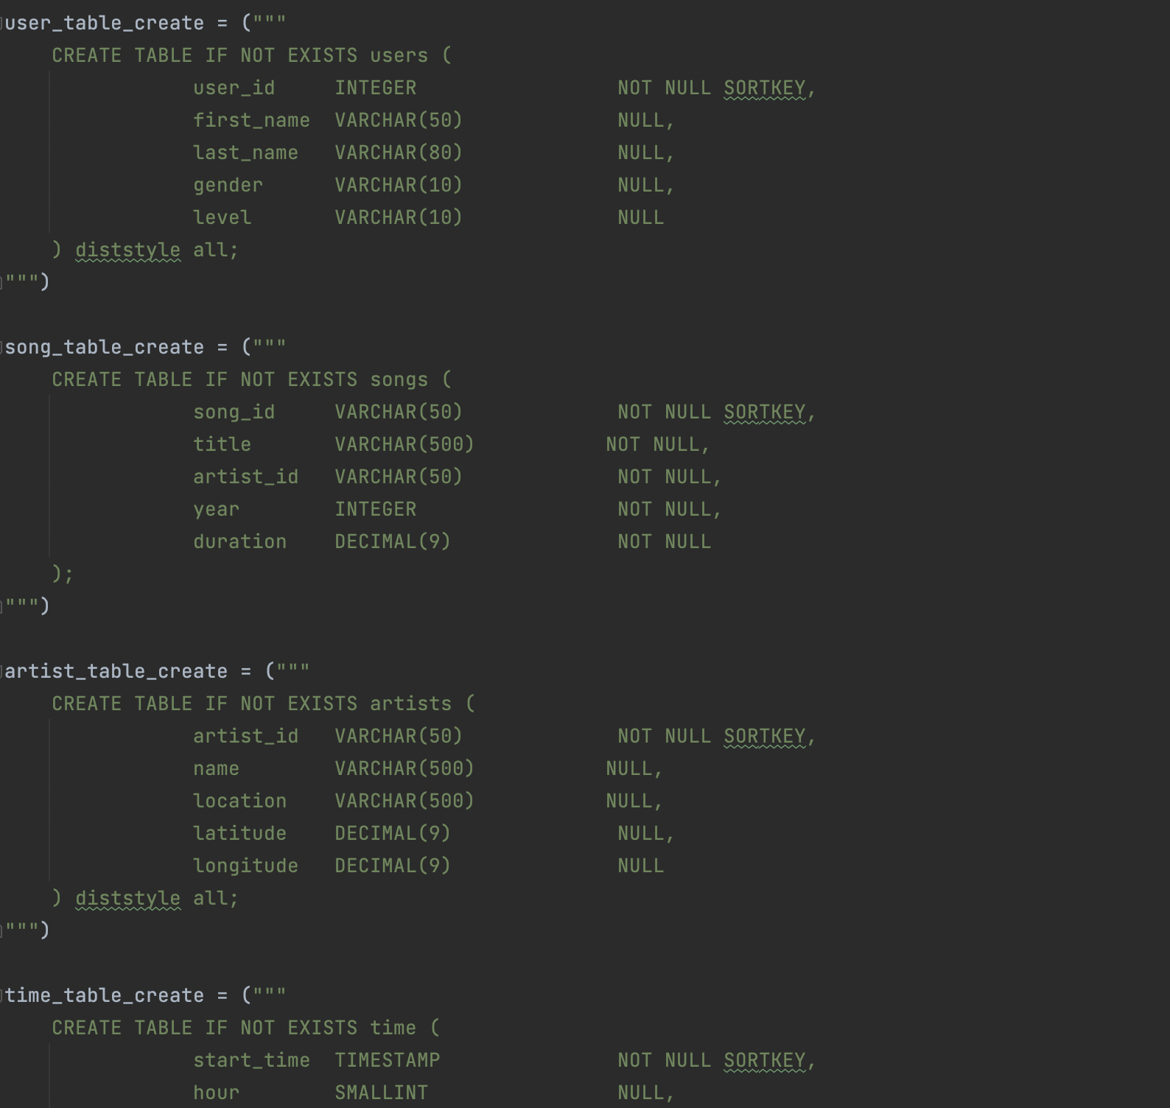

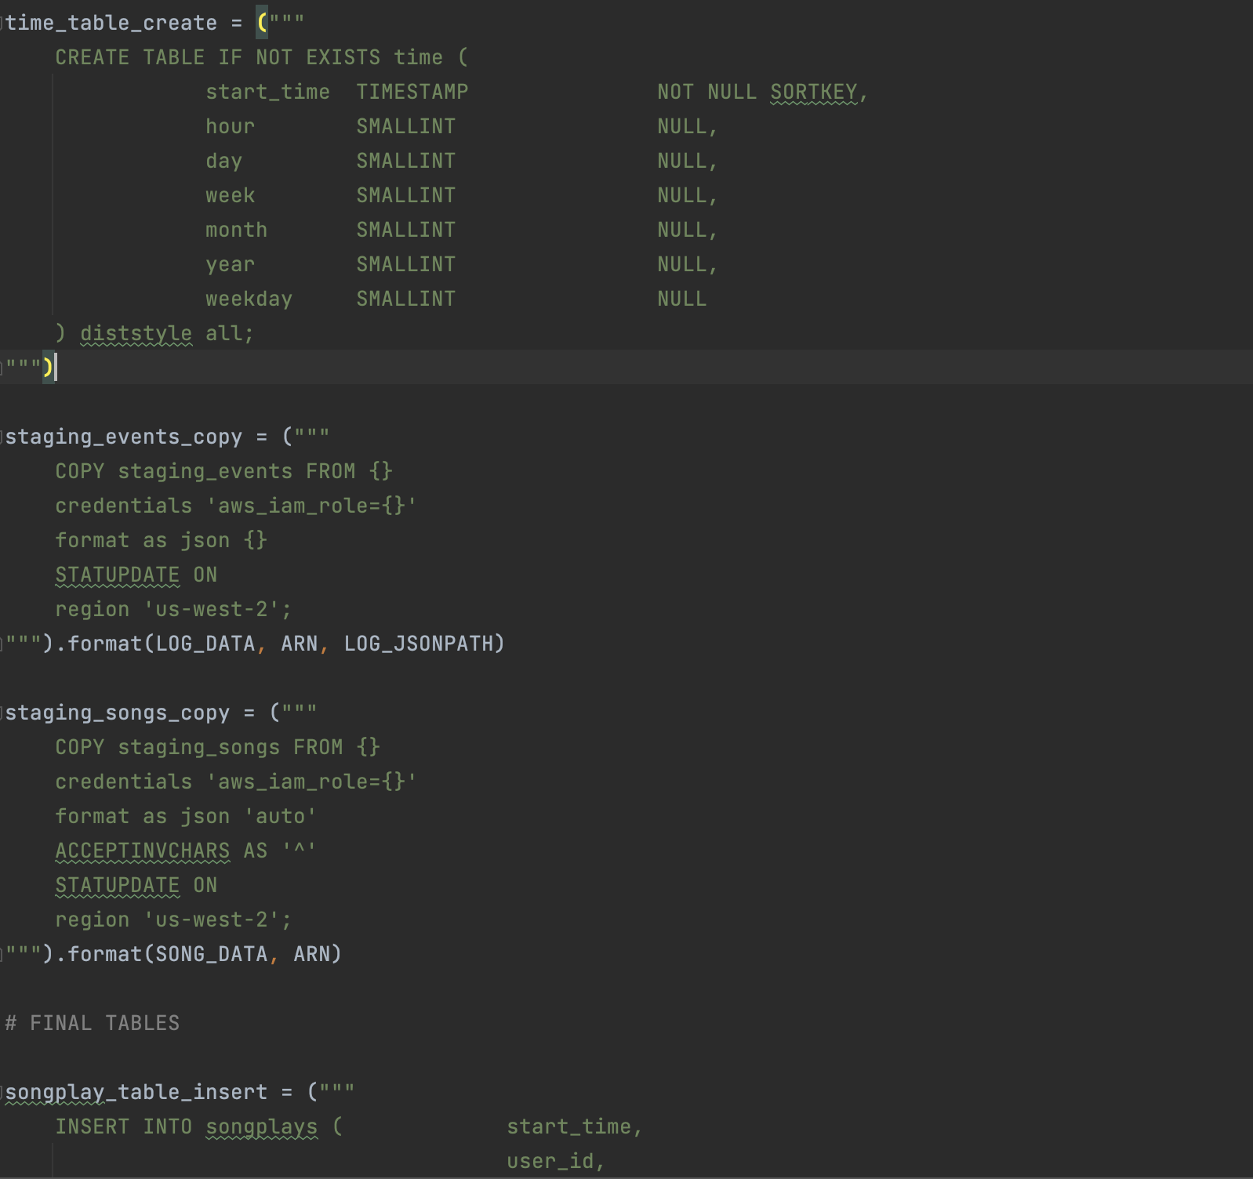

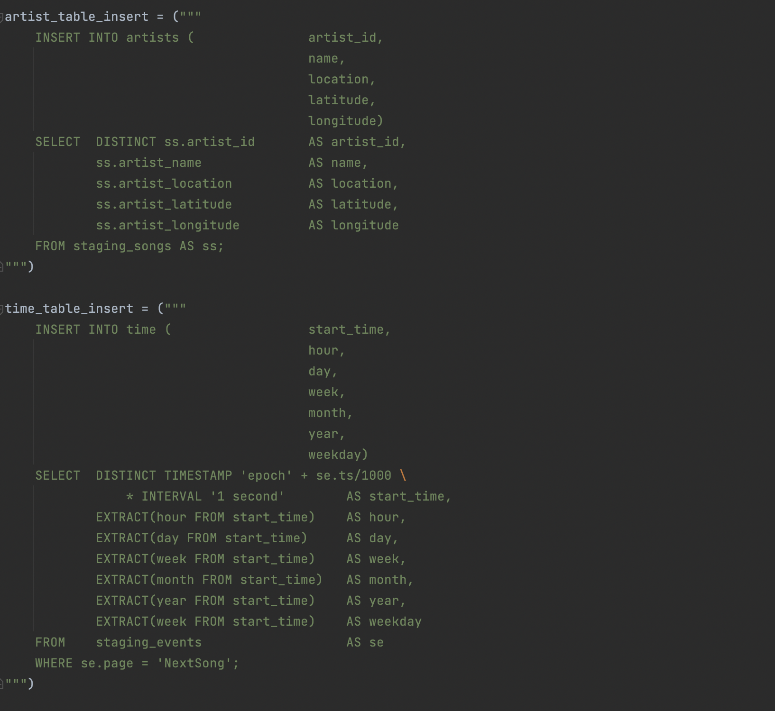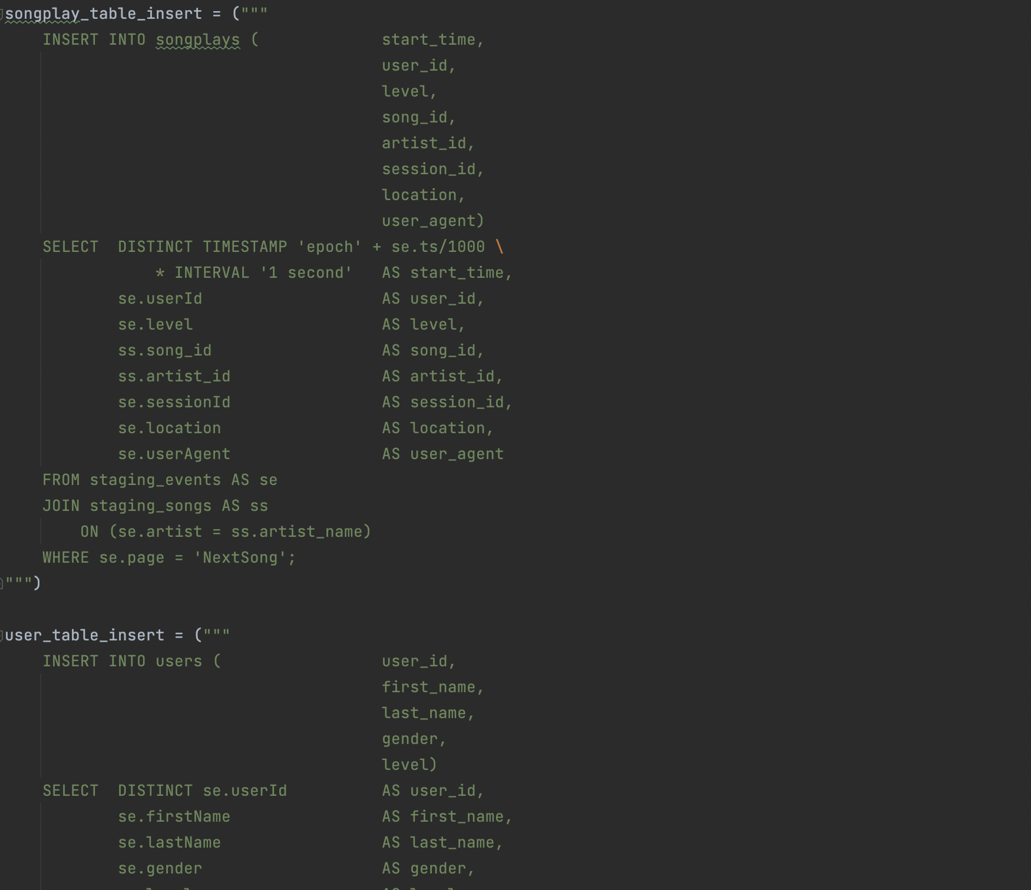

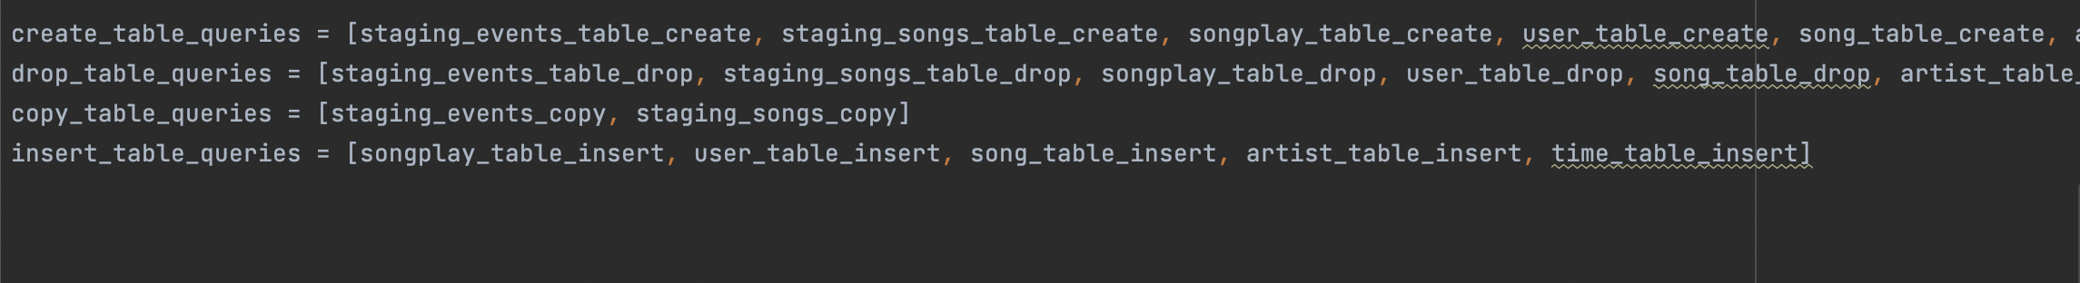

**Database Design:**

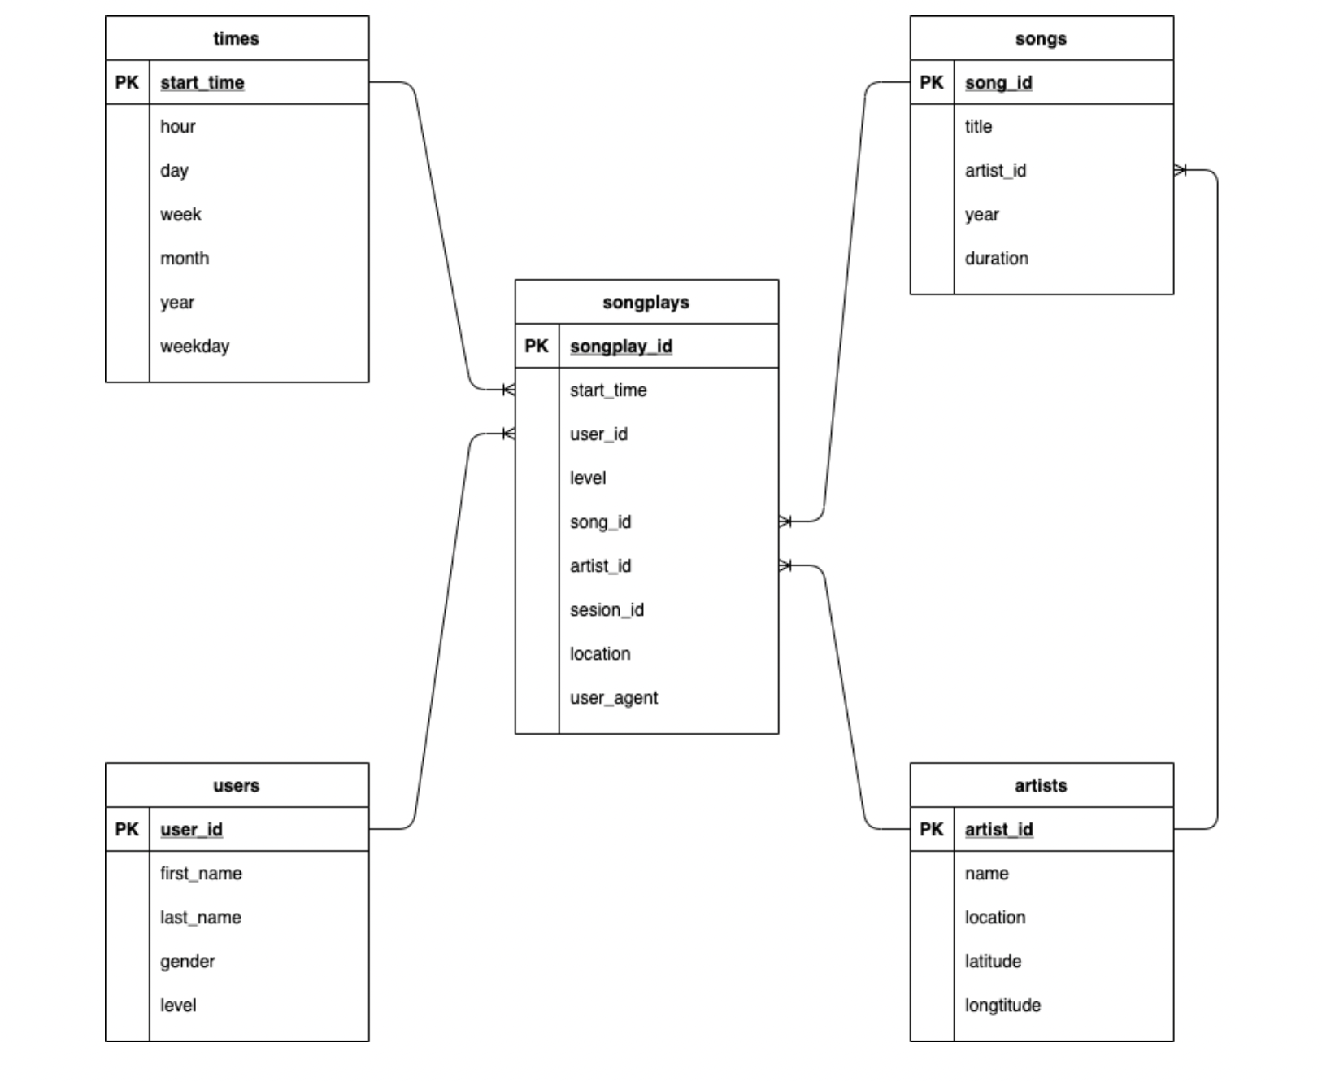

**Implementation Process:**

1. Import required libraries

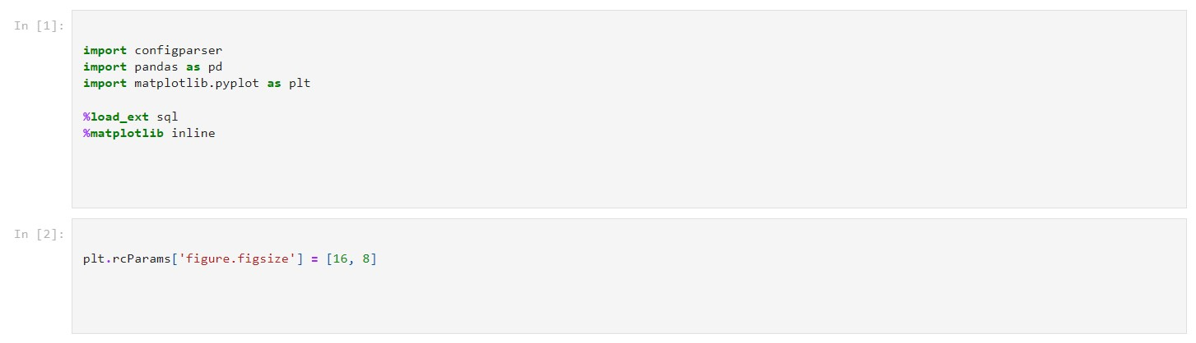

1. Load DWH param from a file and configure Apache kafka

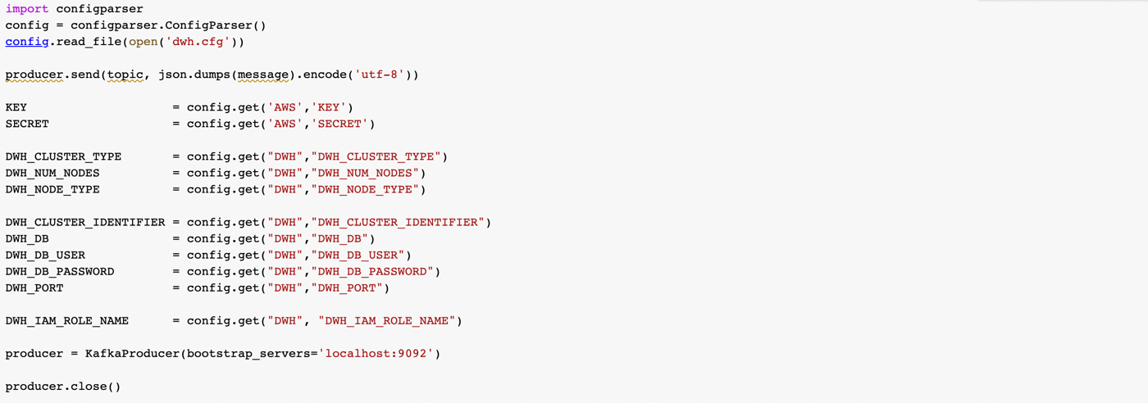

1. Create an IAM role

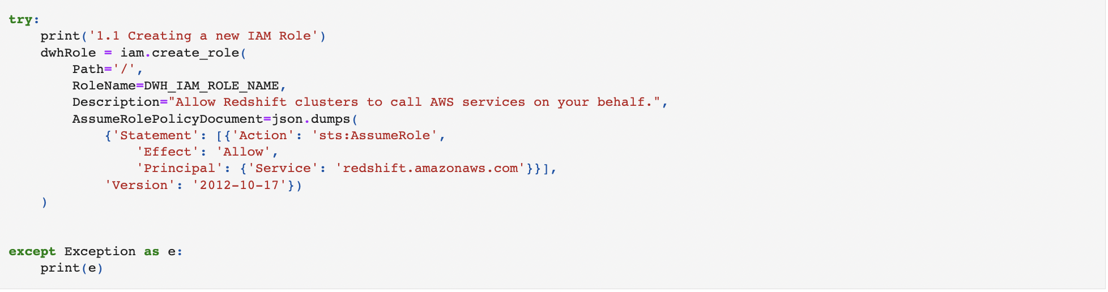





1. Create Redshift Cluster:

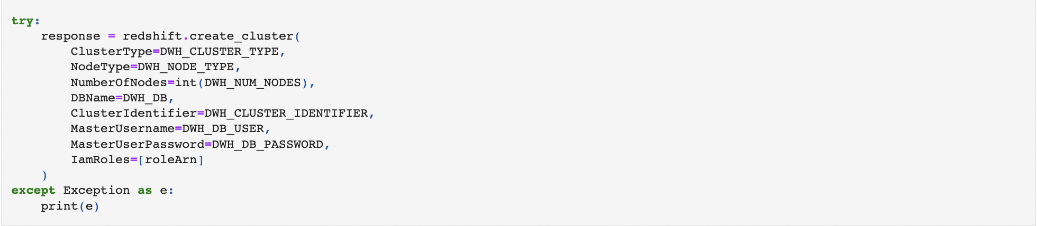

1. **Analytics Queries:**

**Popular Artists:**

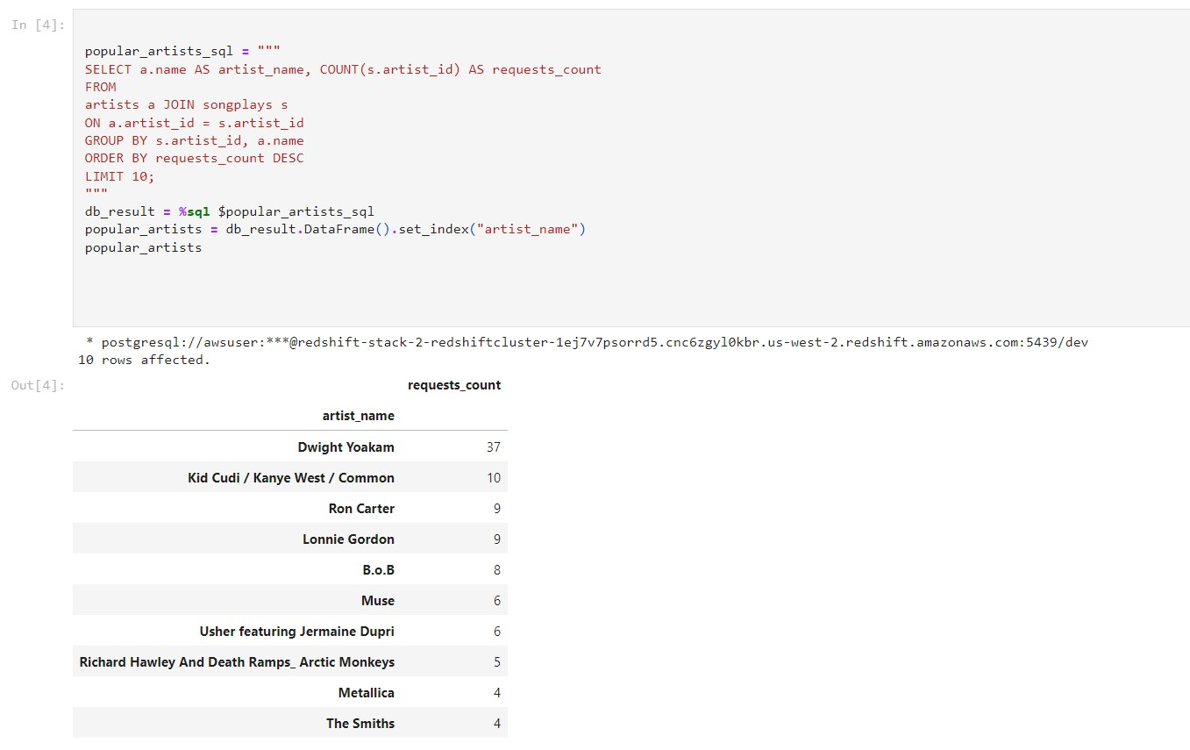

**Popular Songs:**

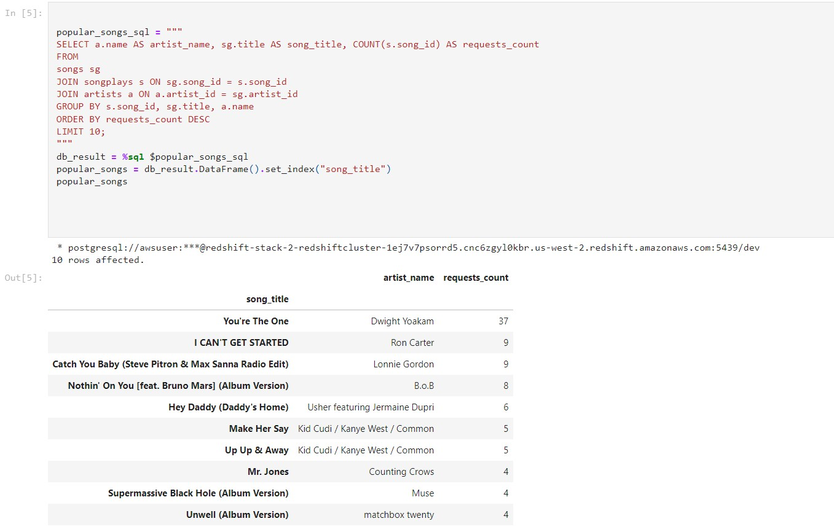

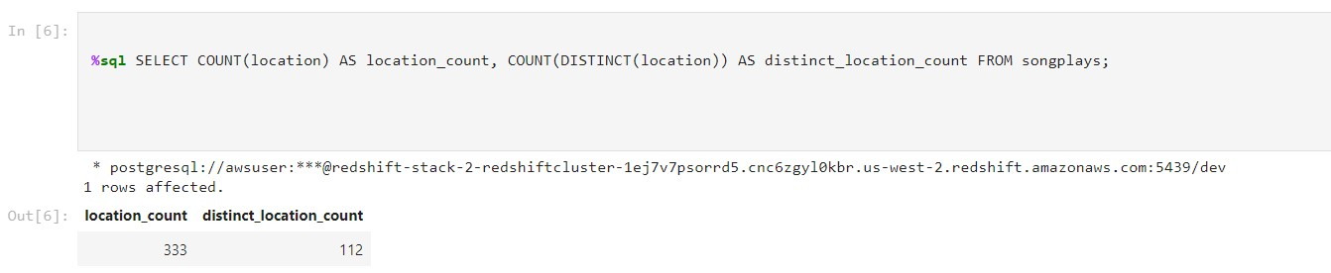

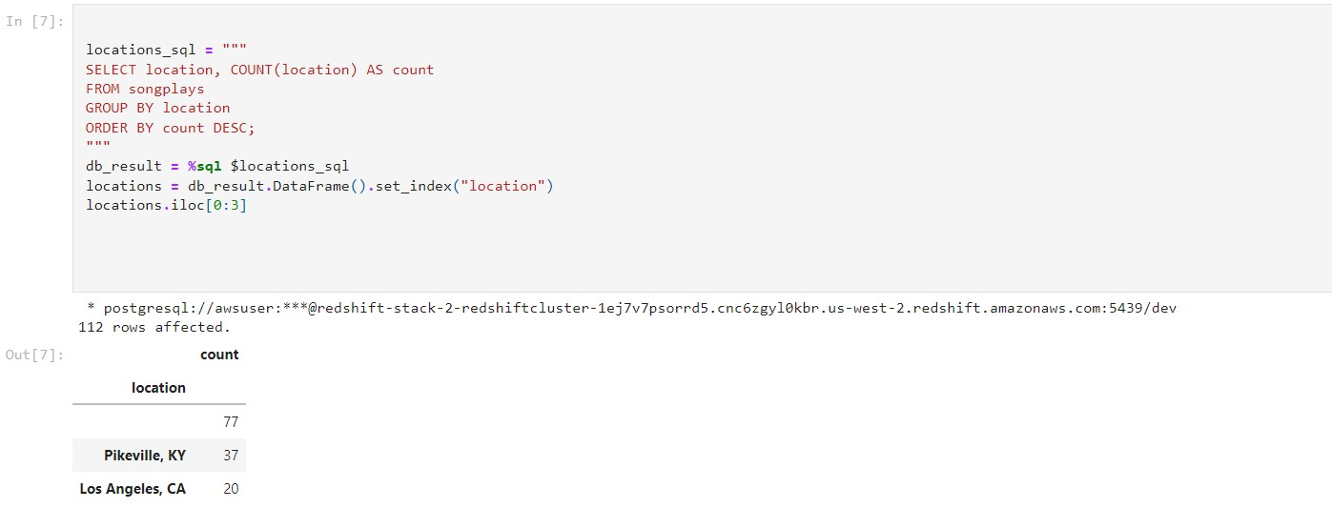

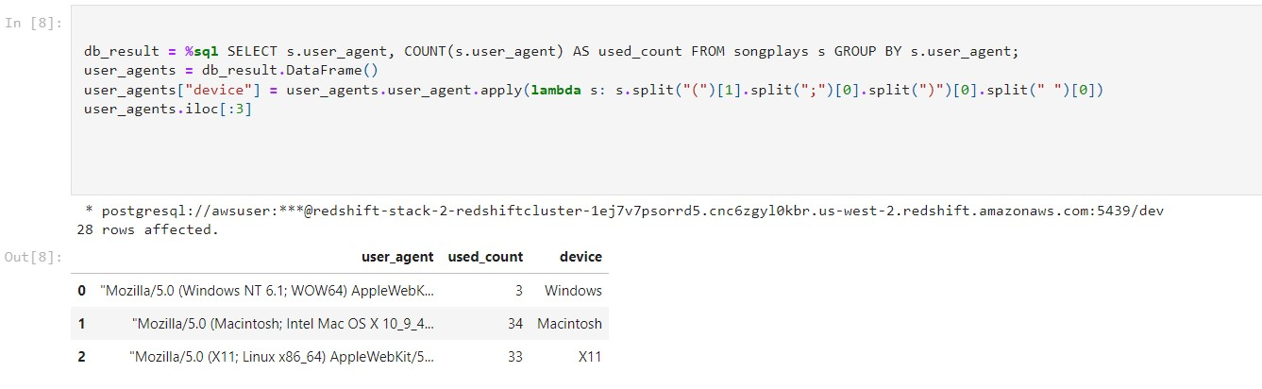

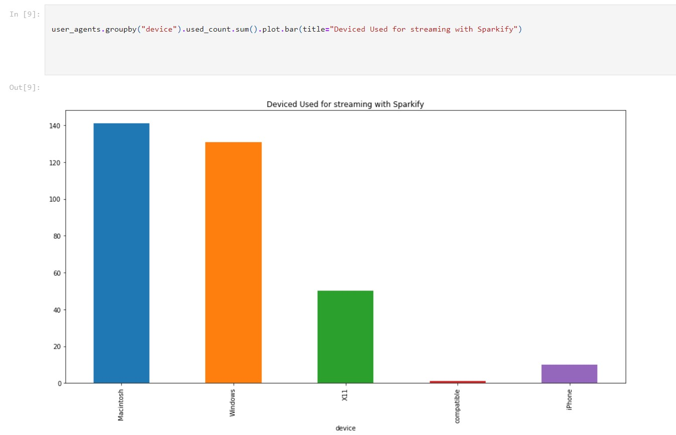

**Time Usage Of the App:**

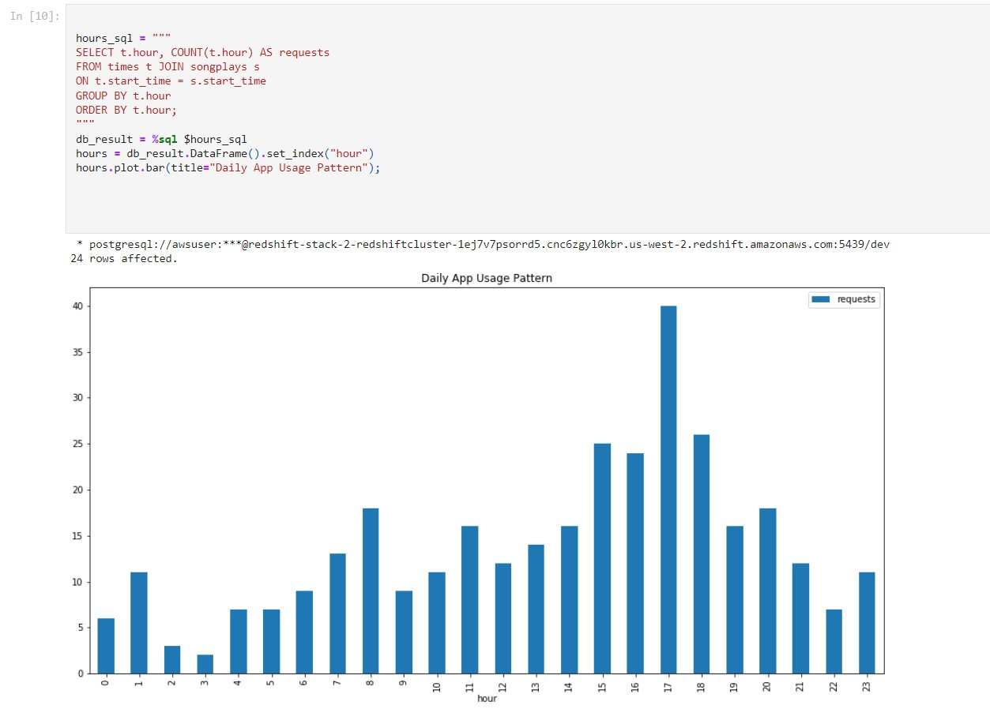

**Weekly App Usage Pattern:**

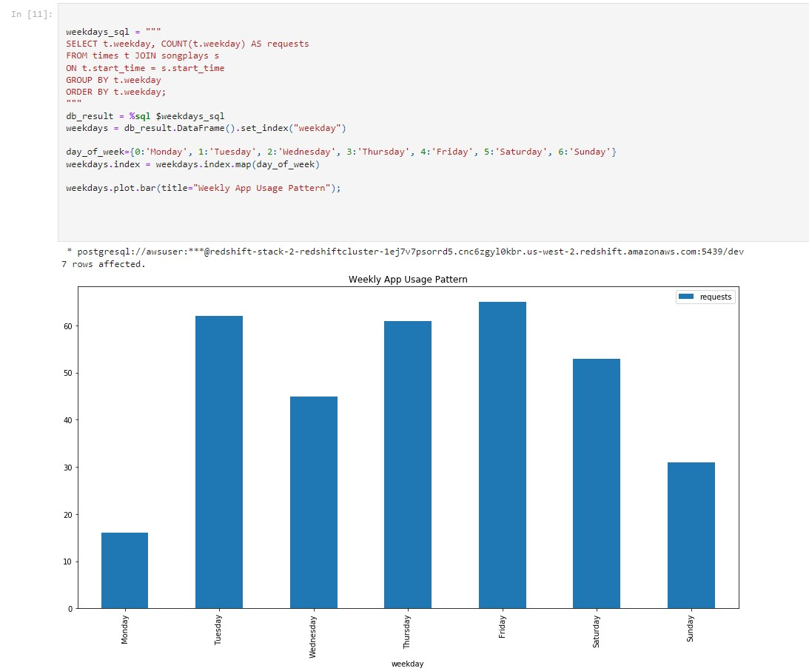

**Conclusion**:

The aim of this project is to present the execution of a Data Warehouse for a hypothetical music streaming startup. The proposed system using Apache Kafka has the potential to generate valuable insights that can help improve the app's user experience. Ensuring that the data is properly organized and stored in real-time using Kafka topics is crucial for achieving the project's objective.

**Bibliography:**

Amazon Redshift: <https://aws.amazon.com/redshift/>

<https://docs.aws.amazon.com/whitepapers/latest/big-data-analytics-options/amazon-redshift.html>

Apache Kafka: <https://kafka.apache.org/>

OLAP.com: <https://www.olap.com/olap-definition/>

<https://aws.amazon.com/solutions/case-studies/wynkmusic/>

<https://medium.com/@deepaksethi.ocp/aws-redshift-whitepaper-84e013272841>

<https://www.snowflake.com/data-cloud-glossary/sql/>

<https://www.ctepl.com/blog/lower-your-costs-of-running-data-warehouse-through-amazon-redshift/>

<https://www.researchgate.net/publication/300581416_Amazon_Redshift_and_the_Case_for_Simpler_Data_Warehouses>

GitHub Link: <https://github.com/mmitalidis/udacity/tree/main/data_engineering/redshift>

Top of Form

Bottom of Form

Bottom of Form